A.1 Aim:
Design Test cases for white box testing (Independent path)

Coding
Inta,found=0;(1)

Char b_name[30],subject[30],author[30];
Void Search( ) (2)
{

cout<<”\n (1) SEARCH BY BOOK NAME :”;
cout<<”\n (2) SEARCH BY SUBJECT & AUTHOR :”; (3)
cin>>a;
if(a==1) (4)
{
gets(b_name); (5)
while(!ifile.eof() && found==0) (6)
{
ifile.read((char*)&S1,sizeof(detail)); (7)
if(strcmp(b_name,S1.book_name)==0) (8)
found=1; (9)
}
}
else (10)
{
gets(subject); (11)

gets(author);
while(!ifile.eof()) (12)
{
ifile.read((char*)&S1,sizeof(detail)); (13)
if(strcmp(subject,S1.subject)==0&&strcmp(author,S1. author)==0) (14)
print(s1); (15)
}
}
} (16)

Testing

7.1Flowgraph

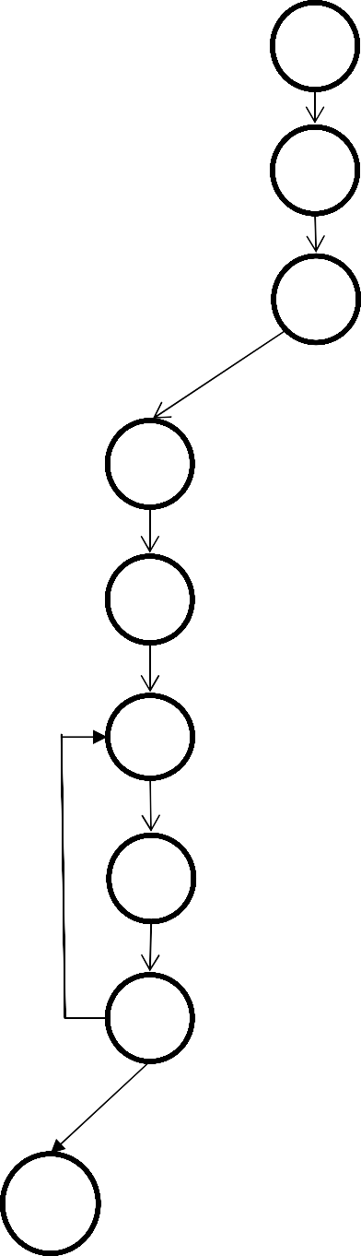

1
2
3
4
10
5
11
6
12
7
13
8
14
9
15
16



Paths:

Path 1: 1 2 3 4 5 6 16

Path 2: 1 2 3 4 5 6 7 8 6….

Path 3: 1 2 3 4 5 6 7 8 9 6…

Path 4 : 1 2 3 10 11 12 16

Path 5: 1 2 3 10 11 12 13 14 12…

Path 6: 1 2 3 10 11 12 13 14 15 12…

Cyclomatic Complexity

Using Regions: -

Number of regions = 6
Therefore, cyclomatic complexity = 6 Using Edges & Nodes: -
Number of Edges (E) = 20 Number of Nodes (N) =16 V (G) = E – N + 2
=20 – 16 + 2
=6
Therefore, cyclomatic complexity = 6 Using Predicate Nodes: -
No. Of predicate Nodes (P) =5 V (G) = P+1
=5+1
=6
Therefore, cyclomatic complexity = 6

  - Test cases
Test Case 1: P1:

When the user enters, ‘Y’(to the Ques. that whether he knows the book name). Then the User enters the book name. ,
Program enters in While loop but the file does not exist or is empty.

& it exits

Test Case 2: P3:

When the user enters , ‘Y’(to the Ques. that whether he knows the book name.). Then the User enters the book name.
Then the program enters in While loop, searches the whole file & the corresponding book name is found.

& it exits

Test Case 3:P2:

When the user enters, ‘Y’(to the Ques. that whether he knows the book name). Then the User enters the book name.
Then the program enters in While loop, searches the whole file but the corresponding book name is not found.
& it exits

Test Case 4:P4:

When the user enters ‘N’(to Ques. that whether he knows the book name.) Then the user enters the subject and course name.
Program enters in While loop but the file does not exist or is empty.

& it exits.

Test Case 5:P5:

When the user enters ‘N’ (to the Ques. that whether he knows the book name)

Then the user enters the subject and course name.

Then the program enters in While loop, searches the whole file but the corresponding set of subject and course name is not found.
& it exits.

Test case 6: P6:

When the user enters ‘N’(to the Ques. that whether he knows the book name) Then the user enters the subject and course name.
Then the program enters in While loop , searches the whole file & the corresponding sets of subject and course name is found.

& it exits.

**Advantages and disadvantages of white box testing.
Advantages / Pros of White Box Testing
· Code optimization by revealing hidden errors
· Transparency of the internal coding structure which is helpful in deriving the type of input data needed to test an application effectively
· Covers all possible paths of a code thereby, empowering a software engineering team to conduct thorough application testing
· Enables programmer to introspect because developers can carefully describe any new implementation
· Test cases can be easily automated
· Gives engineering-based rules to stop testing an application.

Disadvantages / Cons of White Box Testing
· A complex and expensive procedure which requires the adroitness of a seasoned professional, expertise in programming and understanding of internal structure of a code
· Updated test script required when the implementation is changing too often
· Exhaustive testing becomes even more complex using the white box testing method if the application is of large size
· Some conditions might be untested as it is not realistic to test every single one
· Necessity to create full range of inputs to test each path and condition make the white box testing method time-consuming
· Defects in the code may not be detected or may be introduced considering the ground rule of analysing each line by line or path by path.

A.1 Aim:
Using any SCM tool perform change specification and make different version
PROCEDURE:
• Create new repository
• Upload the file that need to be changed
• Commit the operation
• Edit the uploaded file as per the user requirement
• Commit the changes
• View on History the two versioned file with different hashtag values
• Click on the hashtag of updated file and view the changes happened on which code

A.1 Aim:
To prepare the RMMM Plan.
Risk Management
Risk components:
(1) Performance risk—the degree of uncertainty that the product will meet its requirements and be fit for its intended use.
(2) Cost risk—the degree of uncertainty that the project budget will be maintained.
(3) Support risk—the degree of uncertainty that the resultant software will be easy to correct, adapt and enhance.
(4) Schedule risk—the degree of uncertainty that the project schedule will be maintained and that the product will be delivered on time.
· Impact of each risk driver on the risk component is divided into one of four impact categories—negligible, marginal, critical, or catastrophic

Figure 1 - Risk Characterization Table

Support
Cost
Schedule
Catastrophic
Nonres.:p:;iiYet' or l!ll"l5Upporfobfe software
Si9ni it;;anllinonci1;1I shorto@es, born;lg:el overrun I' ly
Uoo::hi le
IOC
Critical
1
Faul'l,!i !Qi inMI 1he r.equire;ni ni WQuld d119tode tytlam performance o a point wflcre m uioA swcce$$ i= q,.icsllonob11e
2
Some redUClron in lechnicQI p
I
Sorr. shortQge oi finQncial re$Ql,lrclj'.i., pou1bl• ovtm.uu
I
Pou bile dippog;a n IOC
Marginal
1
Failure ro rnee.t he r,11.quiremenl wculd
hULi in degtodolion of
1T1inion

2

Minjmdl ro mall
r.duciion in lef!h11irnl1 perkirmaoce
l!'.espoasive
soft.....ar•
$llpPQrt
Suificisnl financial
res.cu
Negligible
1
Foilure to meet 1he requiremen!
woi:ild resu in missiion fui!ure
Fail1J1 resuli iri int:r!.l!!d r;o.i.is end Jid.ieduli! d!!lorj,with i!'llflecled va[uiU in •XCMS d . $.500K
Signi'licont
degrOOiolion lo
2 nonochrevem nt
af temniool
petfut-maoce
fail1,1r,a reUli$ i11 op ro iiono:I .:,leleyl 1;md/Qr increcI osl with expecisd
vo of $ UIO ro .$.SOOK
MilllOl' del ln rnflwore modiRo:i!Lom
c l.1$, imptXJ.tmd/or rer;;QVeroble sc du lips wlrh - cd value ef:S.IIQ :$100X
Reali•'lic,
ac:h'ovdbl1
$t;ltem,le
1
Fatlure to m!!!(!t lhe
ui "'11 wr.:n.tld
Error l'll!lii!fl5 in minor cot and/or
c1«1I• ina:mvenienll or nongpero ioool M;hedule imfJGci wiifl ,e;icpedad vdl1111
impacl
I
I
o 1redue1io11 i11
!aElmic.al
p
Em.ily upportcb
saftware
of r..u t n :s,1K
Poibre b\ldger
undeRun
Eo:l y aEhiemhle IOC
I
Ho'lt<; (11 Thi poi.ntml consi'Ciu.nc;• of 1.1ndil'ecrtiid KiHwr• il'l'Q $ or ki1..L1s.
{2j The polenlial con3e<qU>en.:ie if the de.sjred outcome i n.ol achieved.
Performance
2
2
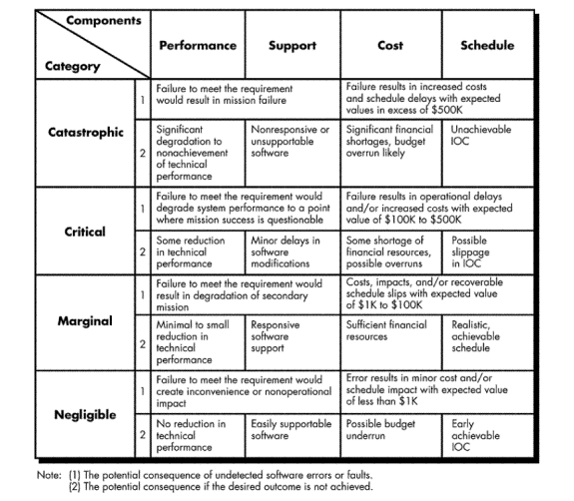

RISK TABLE FOR SENTIMENT ANALYSIS OF DIGITAL BOOKSTORE

Risks | Category | Probability | Impact
Quality is not maintained | PS | 60% | 2
Customer will change requirements | PS | 80% | 3
Staff inexperienced | ST | 30% | 3
Delivery deadline will be tightened | BU | 50% | 2
Lack of cooperation from users | CU | 30% | 1
Lack of effective project managing technology | BU | 40% | 1
Inadequate estimation of required resources | PS | 50% | 1
Loss of database | PS | 50% | 1
Developing a wrong user interface | DE | 70% | 2

PS – Product Size IMPACT VALUES
BU- Business Impact 1.CATASTROPHIC
CU- Customer Characteristics 2.CRITICAL
DE- Development environment 3.MARGINAL
ST- Staff Size 4.NEGLIGIBLE

RISK INFORMATION SHEET
RISK ID: DA-AS232 | DATE:10/04/15 | PROB: 50% | IMPACT: CATASTROPHIC
DESCRIPTION:

Due to various technical reasons or natural calamities, the Database of the system may be lost or damaged.

Refinement:

Subcondition1: Certain checkpoints are recorded in the system periodically

Sub Condition 2:As a part of check-pointing, after every update in the database, checkpoints are updated which states that the database is updated correctly till that point.
Mitigation/Monitoring:

- A copy of all the databases must be maintained side by side on a different system. Also, it must be updated simultaneously.

- A recovery tool must be designed which could recover the database according to the checkpoints.
Management

A special team is allocated for the recovery of the database as soon as possible. The secondary databases which were maintained as a copy must be made primary so that the working of the software is not affected.
Case Study:
Scope and intent of RMMM activities
The goal of the risk mitigation, monitoring and management plan is to identify as many potential risks as possible.
The project will then be analyzed to determine any project-specific risks.
When all risks have been identified, they will then be evaluated to determine their probability of occurrence, and how Digital Bookstore will be affected if they do occur. Plans will then be made to avoid each risk, to track each risk to determine if it is more or less likely to occur, and to plan for those risks should they occur.
It is the organization’s responsibility to perform risk mitigation, monitoring, and management in order to produce a quality product. The quicker the risks can be identified and avoided, the smaller the chances of having to face that particular risk’s consequence. The fewer consequences suffered as a result of a good RMMM plan, the better the product, and the smoother the development process.
Risk management organizational role
Each member of the organization will undertake risk management. The development team will consistently be monitoring their progress and project status to identify present and future risks as quickly and accurately as possible. With this said, the members who are not directly involved with the implementation of the product will also need to keep their eyes open for any possible risks that the development team did not spot. The responsibility of risk management falls on each member of the organization.

Class Diagram:
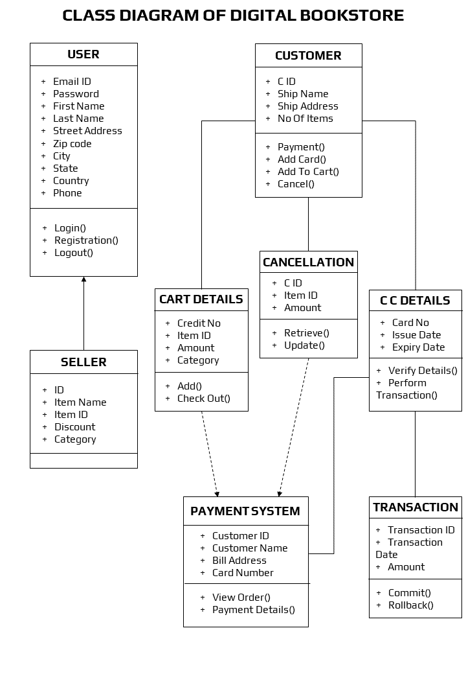
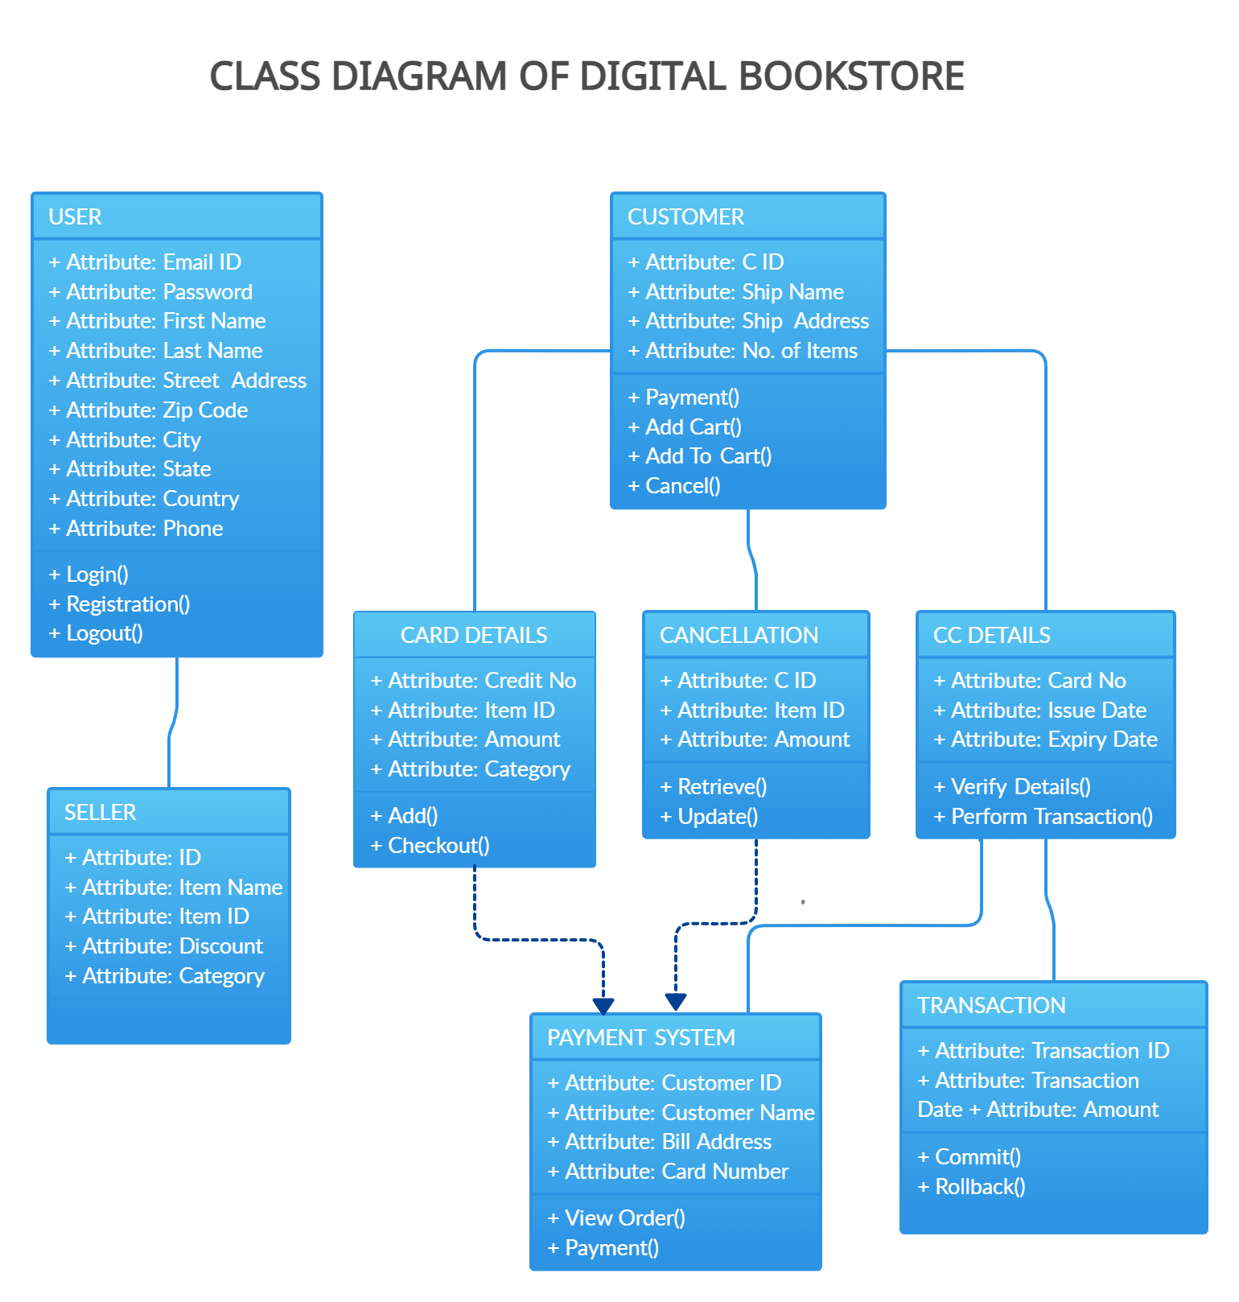

Sequence Diagram:
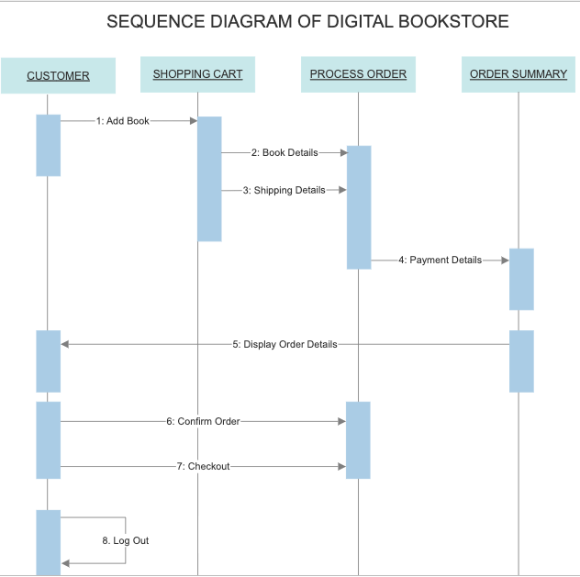
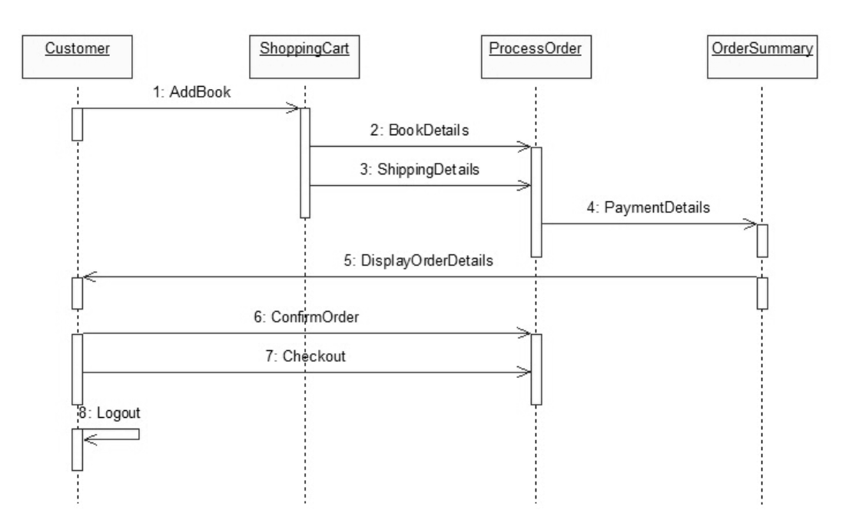

Collaboration Diagram:

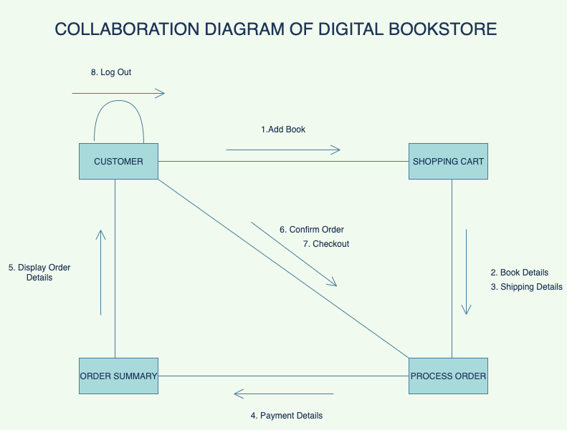

Statechart Diagram:

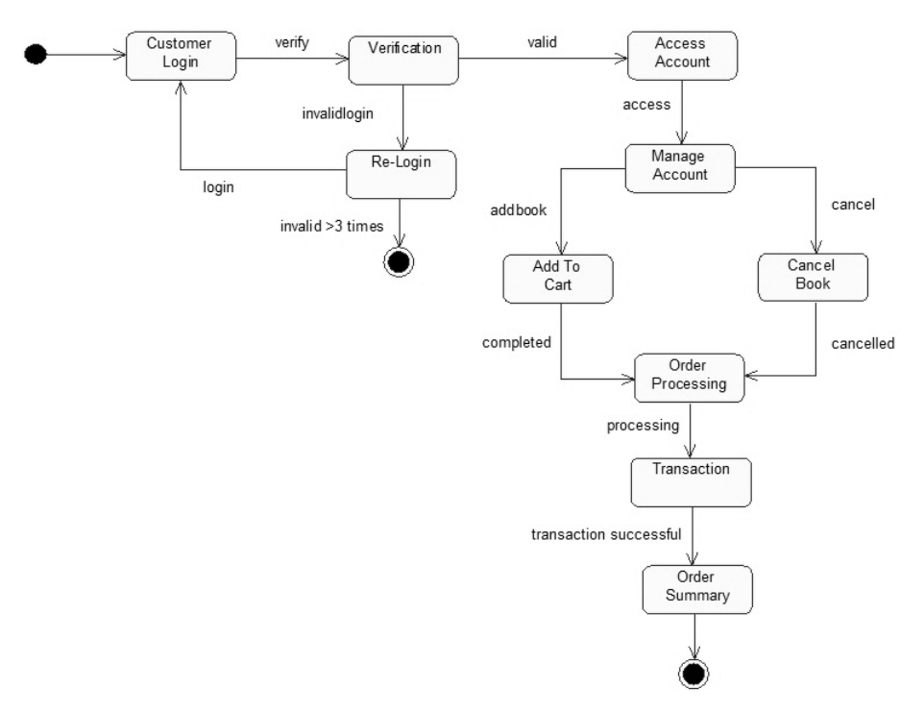

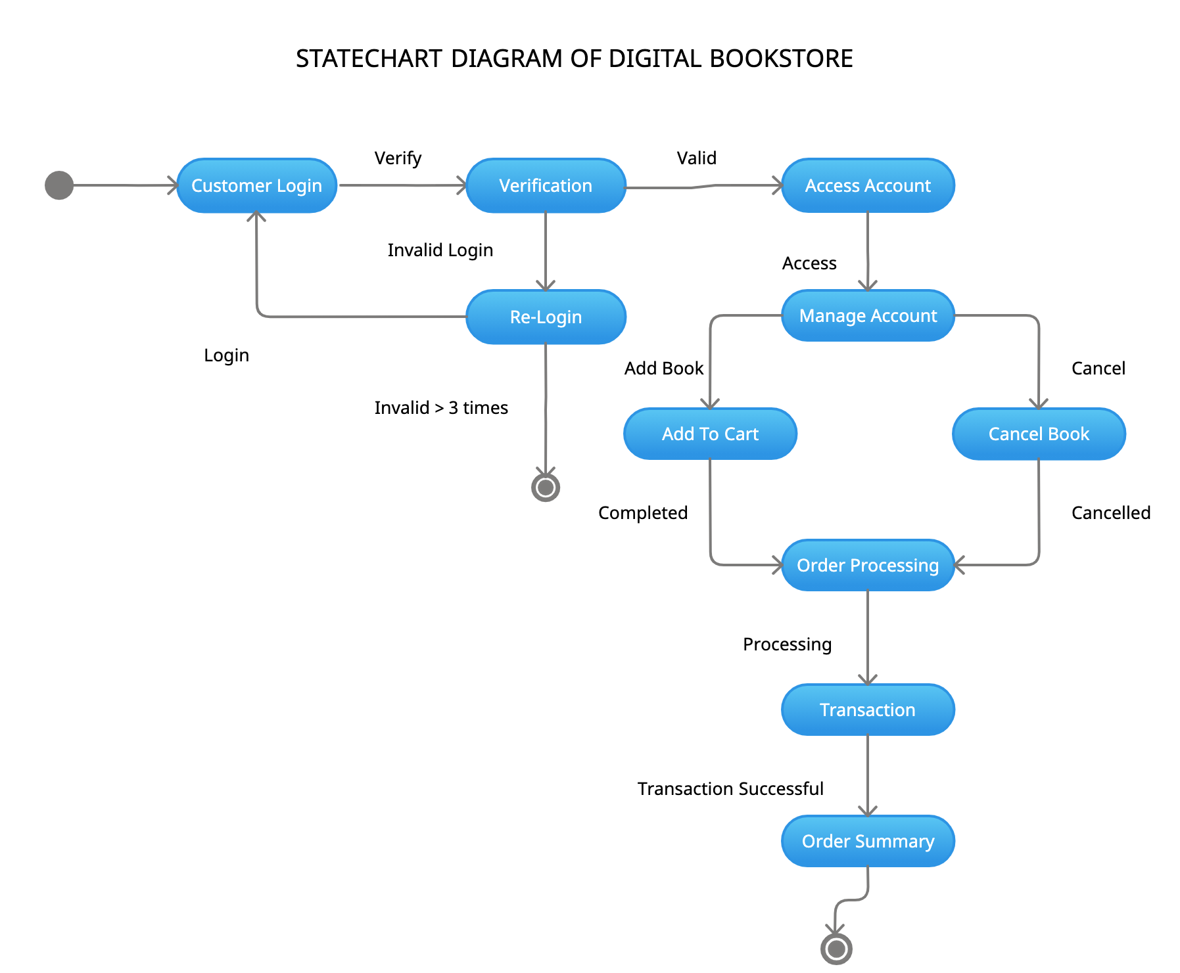

Activity Diagram:
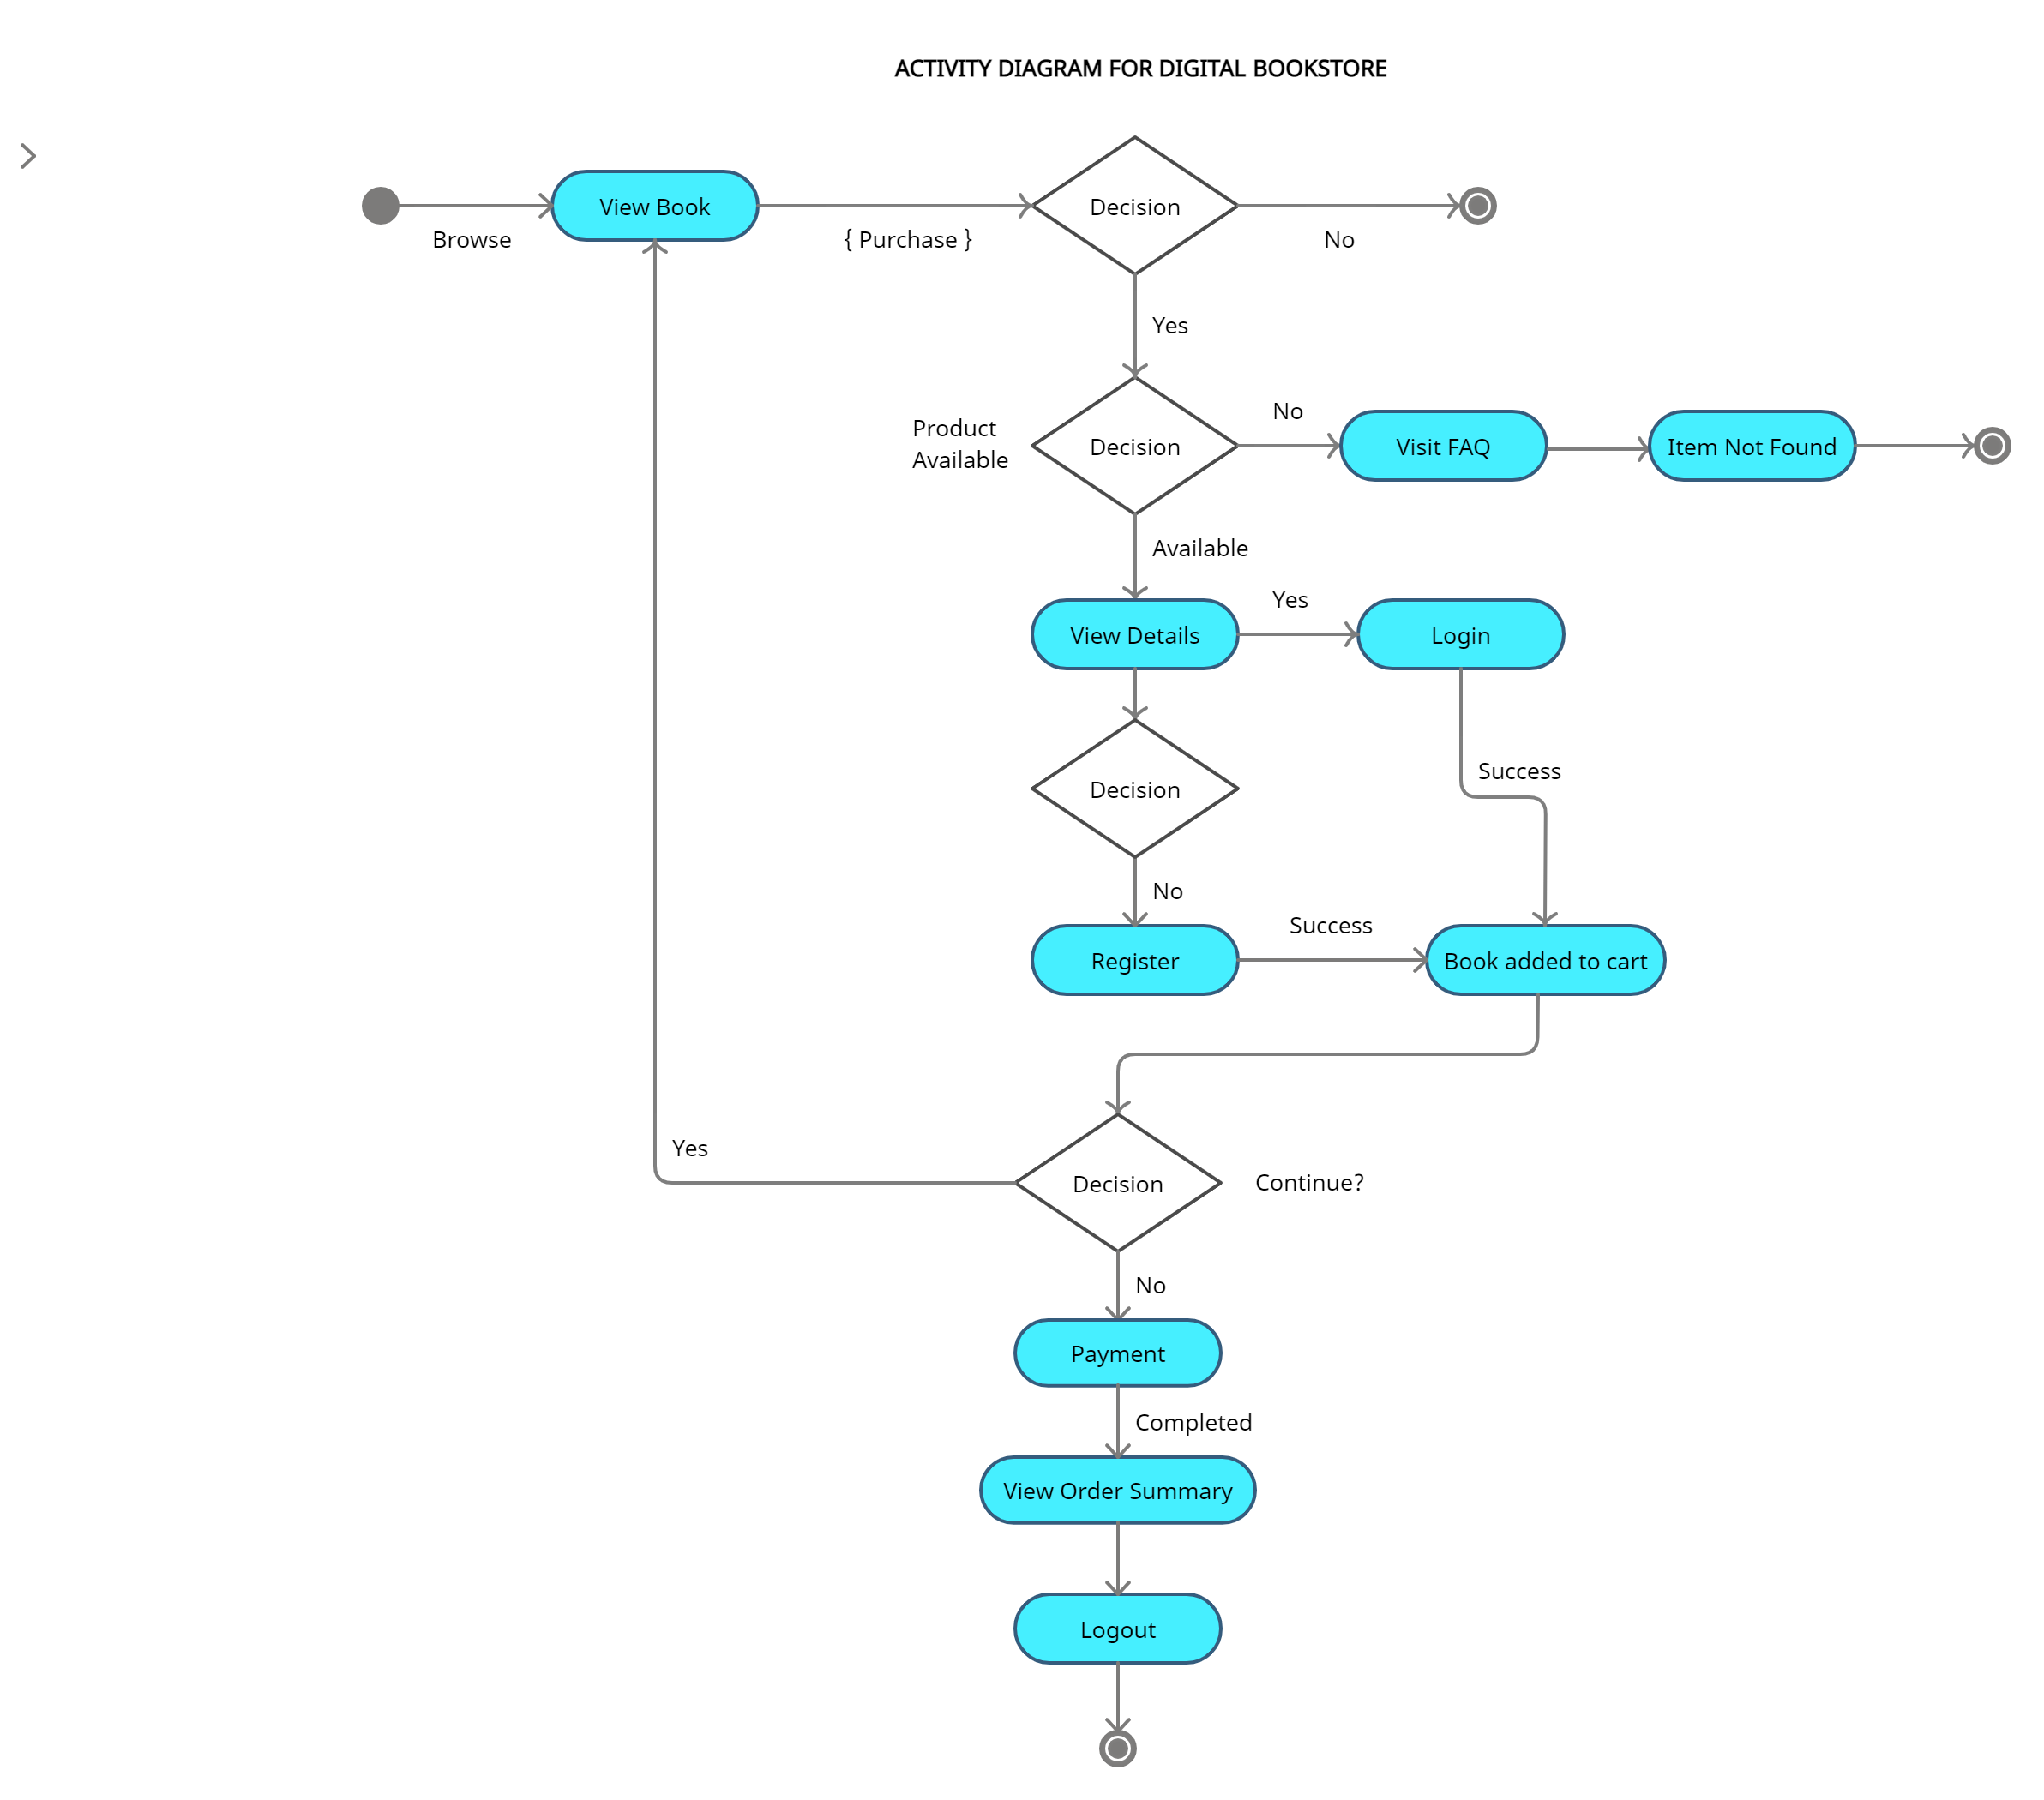

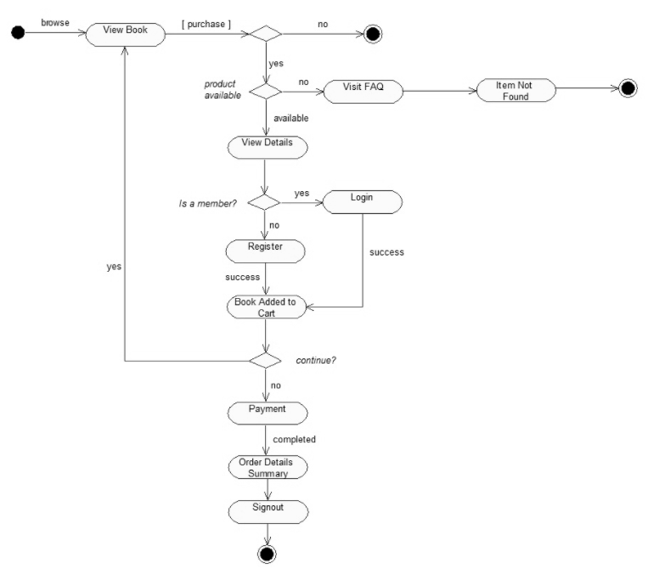

Component Diagrams:
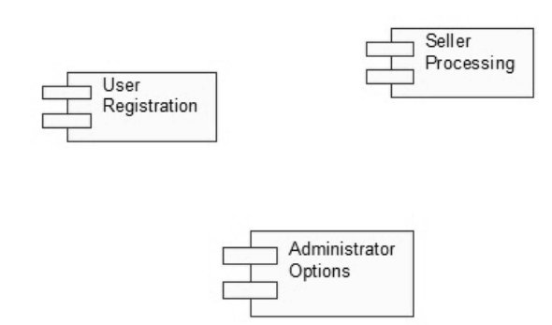
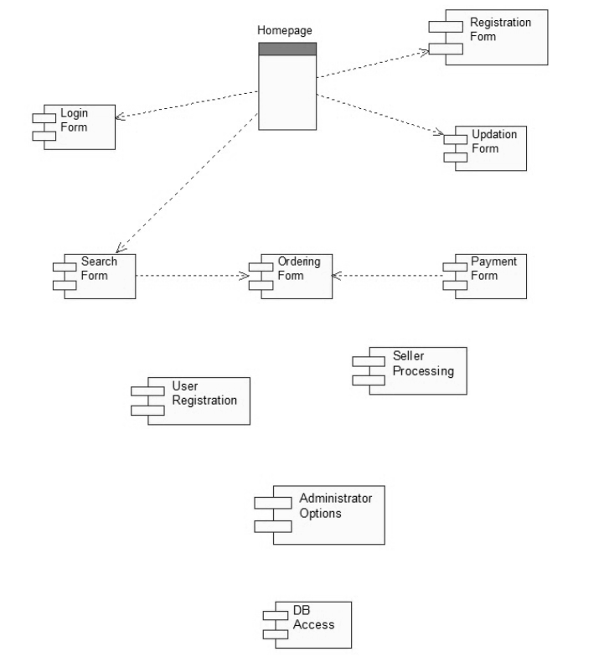

Deployment Diagram:
